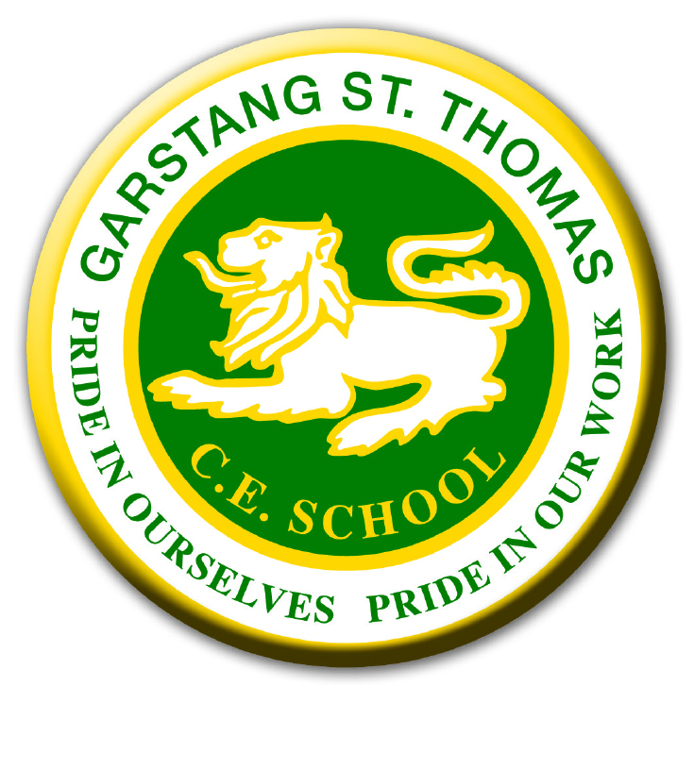
GARSTANG ST THOMAS CHURCH OF ENGLAND SCHOOL
Part 2 - Registration Form for Breakfast/ After School Club 2023/2024
Name(s) of child/ren……………………………………………………………………………
For 2023/2024 – Monday 4th September 2023 to Thursday 18th July 2024

 | Monday | Tuesday | Wednesday | Thursday | Friday
Breakfast Club
After school Club

I agree to the terms and conditions of the breakfast club and after school club.
Signed………………………………………………Date………………………………………
Name of Parent/Carer(s)……………………………………………………………………..
Email Address……………………………………………………………………………………

Contacting us about breakfast club/ after school club:
Mrs Williams our office manager is the extended services manager for the school. Please contact by e-mailing: office@garstang-st-thomas.lancs.sch.uk
or by telephone on: 01995 603454.

The bookings on this form will be confirmed for the whole academic year. All bookings must be booked and paid for online via Parentpay. 4 weeks’ notice is required for any changes.

