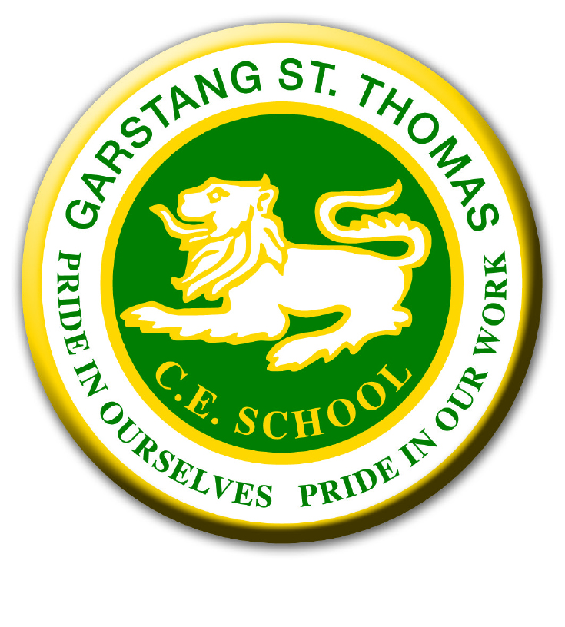
GARSTANG ST THOMAS CHURCH OF ENGLAND SCHOOL
Registration Form for Breakfast/ After School Club 2025/2026
Name(s) of child/ren……………………………………………………………………………
For 2025/2026 – 3rd September 2025 to 17th July 2026

 | Monday | Tuesday | Wednesday | Thursday | Friday
Breakfast Club
After school Club

I agree to the terms and conditions of the breakfast club and after school club.
Signed………………………………………………Date………………………………………
Name of Parent/Carer(s)……………………………………………………………………..
Email Address……………………………………………………………………………………

Contacting us about breakfast club/ after school club:
Mrs Williams our office manager is the extended services manager for the school. Please contact by e-mailing: office@garstang-st-thomas.lancs.sch.uk
or by telephone on: 01995 603454.

The bookings on this form will be confirmed for the whole academic year. All bookings must be booked and paid for online via parentpay.com at least 72 hours prior to the day. All confirmed sessions are chargeable. 4 weeks’ notice is required for any changes.

